Migrate Data to Azure with Atempo Miria

This article helps you integrate the Atempo Miria infrastructure with Azure storage. It includes prerequisites, considerations, implementation, and operational guidance.

Miria enables file and object migrations between many storage platforms. It migrates data from on-premises to Azure quickly, easily, and cost-effectively.

**Table of Content:**

Migrate Data to Azure with Atempo Miria

Reference Architecture

Before You Begin

Implementation Guidance

Start Your Migration

Support

Marketplace

Next steps

# Reference Architecture

The following diagram provides a reference architecture for on-premises to Azure deployments.

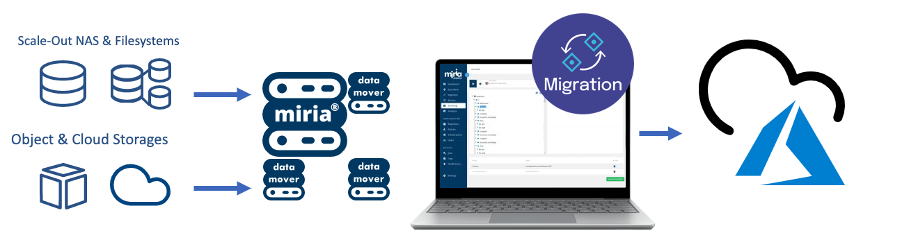

Your existing Atempo Miria deployment can easily integrate with Azure by adding and configuring a connection to Azure, either a standard connection or an ExpressRoute.

# Before You Begin

A little upfront planning will help you use Azure as a target and recovery site.

## Get Started with Azure

Microsoft offers a framework to get you started with Azure. The [Cloud Adoption Framework](https://learn.microsoft.com/en-us/azure/architecture/cloud-adoption/) (CAF) is a detailed approach to enterprise digital transformation and a comprehensive guide to planning a production-grade cloud adoption. The CAF includes a step-by-step [Azure setup guide](https://learn.microsoft.com/en-us/azure/cloud-adoption-framework/ready/azure-setup-guide/) to help you get up and running quickly and securely. You can find an interactive version in the [Azure portal](https://portal.azure.com/?feature.quickstart=true#blade/Microsoft_Azure_Resources/QuickstartCenterBlade). You will find sample architectures, specific best practices for deploying applications, and free training resources to put you on the path to Azure expertise.

## Considerations For Migrations

Several aspects are important when considering migrations of file data to Azure. Before proceeding learn more:

* [Storage migration overview](https://learn.microsoft.com/en-us/azure/storage/common/storage-migration-overview)
* Latest supported features by Miria in [migration tools comparison matrix](https://learn.microsoft.com/en-us/azure/storage/solution-integration/validated-partners/data-management/migration-tools-comparison).

Remember, you need enough network capacity to support migrations without impacting production applications. This section outlines the tools and techniques that are available to assess your network needs.

## Determine Unutilized Internet Bandwidth

It's important to know how much unutilized bandwidth (or headroom) you have available on a day-to-day basis. To help you assess whether you can meet your goals for:

* Initial time for migrations,
* Time required to do incremental resync before final switch-over to the target file service.

Use the following methods to identify the bandwidth headroom that is free to consume.

* If you're an existing Azure ExpressRoute customer, view your [circuit usage](https://learn.microsoft.com/en-us/azure/expressroute/expressroute-monitoring-metrics-alerts#circuits-metrics) in the Azure portal.
* Contact your ISP and request reports to show your existing daily and monthly utilization.
* There are several tools that can measure utilization by monitoring your network traffic at the router/switch level:
  + [SolarWinds Bandwidth Analyzer Pack](https://www.solarwinds.com/network-bandwidth-analyzer-pack?CMP=ORG-BLG-DNS)
  + [Paessler PRTG](https://www.paessler.com/bandwidth_monitoring)
  + [Cisco Network Assistant](https://www.cisco.com/c/en/us/products/cloud-systems-management/network-assistant/index.html)
  + [WhatsUp Gold](https://www.whatsupgold.com/network-traffic-monitoring)

# Implementation Guidance

## Before you begin

This documentation assumes that you already have a Miria Server and Miria Data Mover installed and running on a VM or on a server in your environment. If this is not the case, please refer to the following links for more information regarding:

* + [Miria Server and Data Movers deployment and initial configuration](https://www.atempo.com/privatedocs/Miria_2022_Migration_Documentation.pdf)
  + [Details on platforms and OS versions supported by Miria](http://atempo.com/ressource/miria-compatibility-guide)

The following section will guide you in successive steps:

1. Creating and configuring your Azure BLOB Storage,
2. Creating a Miria Target Storage: Azure BLOB,
3. Creating a Miria Source Storage with SMB/CIFS share
4. Creating and launching your data migration task
5. Checking on progress, logs, and reports at the project and task level
6. Creating additional tasks in your migration project.

## Azure BLOB configuration

This section provides a brief guide for how to add Azure BLOB to an on-premises-to-Azure Miria deployment.

1. Open the Azure portal, and search for **storage accounts**.

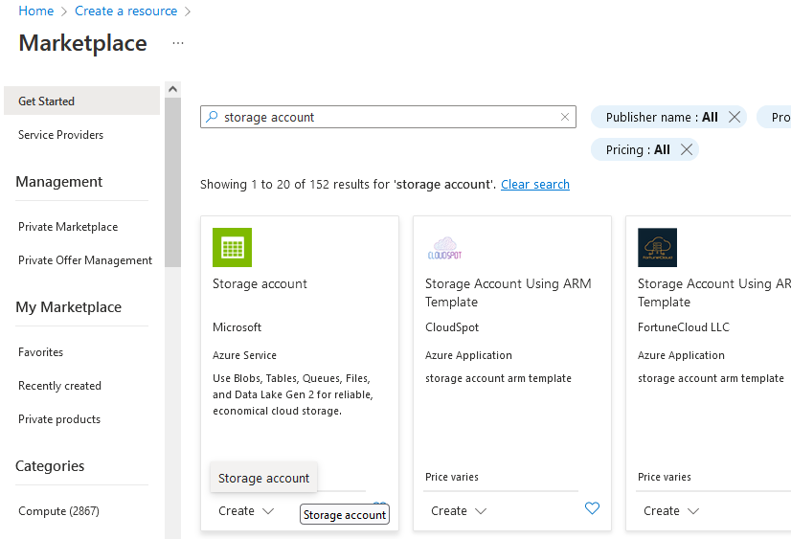

1. Select **Create** to add an account:
2. Select an existing resource group or Create new
3. Provide a unique name for your storage account
4. Select the region
5. Select **Standard** or **Premium** performance, depending on your needs.
6. Select the [**Redundancy**](https://learn.microsoft.com/en-us/azure/storage/common/storage-redundancy) that meets your data protection requirements.

1. Next, we recommend the default settings from the **Advanced** screen.

1. Keep the default networking options for now and move on to **Data protection**. You can select to enable soft delete, which allows you to recover accidentally deleted data within the defined retention period. Soft delete offers protection against accidental or malicious deletion.

1. Add tags for organization if you use tagging and **Create** your account.
2. Another quick step is mandatory before you can add the account to your Miria environment. Navigate to the **Access keys** item under Security + Networking and copy the **Storage account name** and one of the two **access keys**.

1. Under Data Storage, create a Container with a unique name.

1. Optional - Configure extra [security best practices](https://learn.microsoft.com/en-us/azure/storage/blobs/security-recommendations).

## Creating a Miria Target Storage: Azure BLOB

1. In Miria Web UI, you need to declare the Azure storage and the newly created bucket. To do so, navigate to **Infrastructure** in the left pane, then select **Object storage & application**.

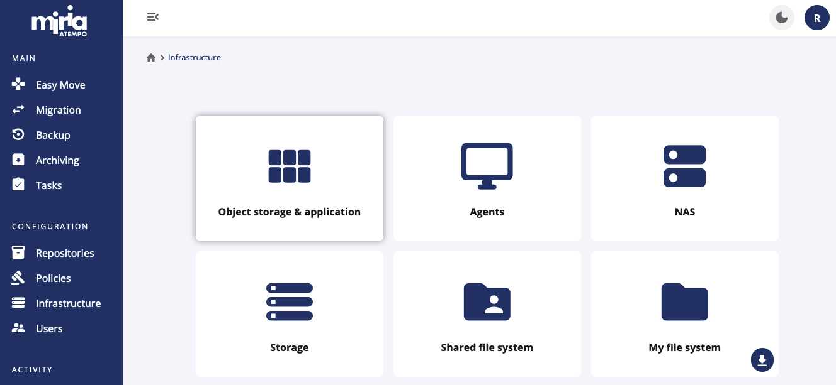

* 1. Click on New Storage Manager button on top right

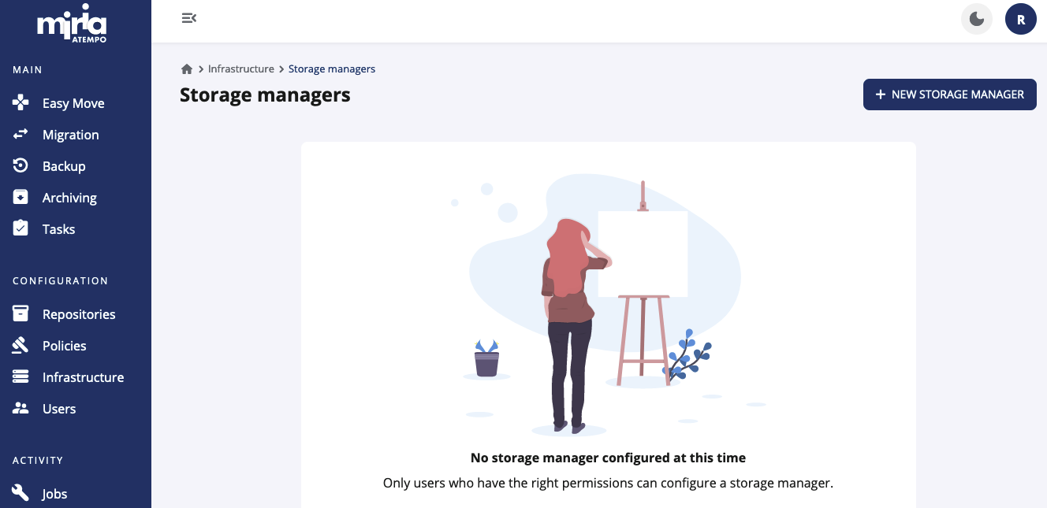

* 1. In the **Type** drop-down list select Microsoft Azure BLOB Block among Cloud entries and click **Next.**

* 1. Select a Storage Manager name (here SM_Azure) and replace placeholder with your Account name in the Network address field:

* 1. In the Default proxy platform drop-down list, select the desired Data Mover or Data Mover Pool (here WIN-H9K5NN91J0H) used to reach out to your Azure storage.

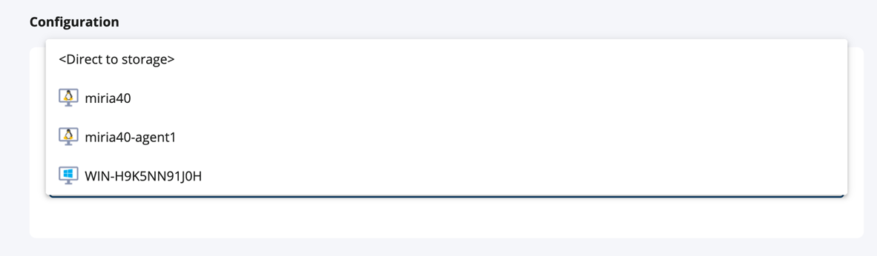

* 1. Click **Create** at the very bottom

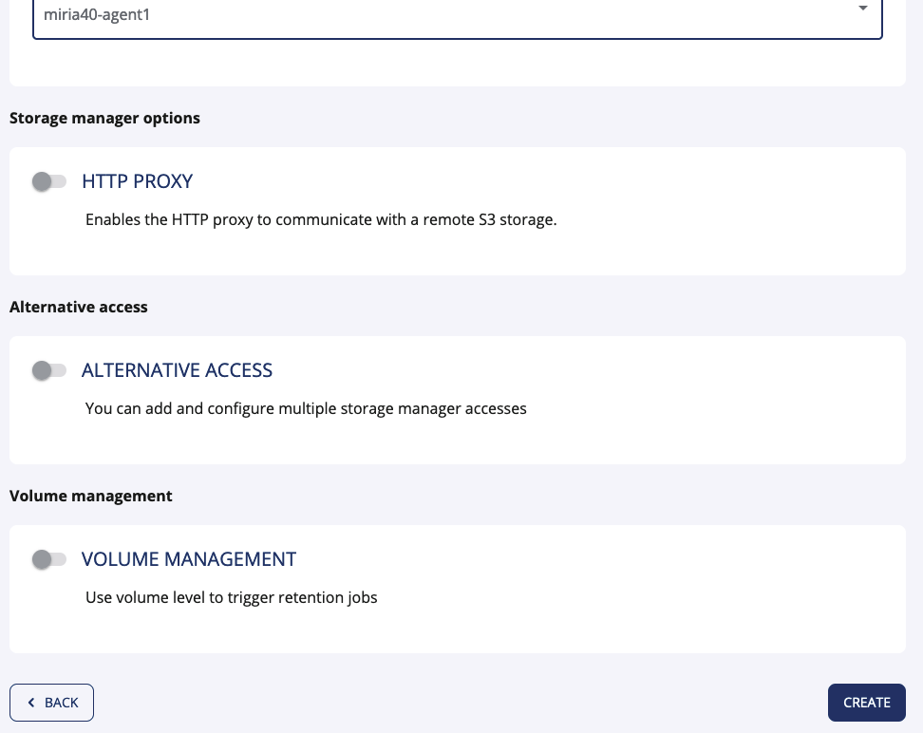

Once the Storage Manager is successfully created, we need to create the Miria container associated to this bucket. To do so, click the **Back** button to display the list of Storage Managers.

* 1. Click on the three dots located at the end of the line associated to the Storage Manager we just created and select **Add** **Container**

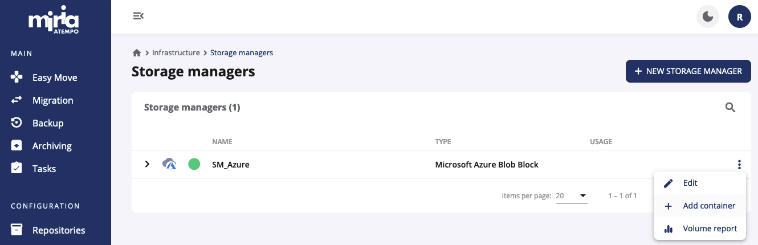

* 1. Select a Storage Manager Container name (here SMC_Azure) and activate the toggle **Available as Source** to support future workflows. Name the source **platform** (here Azure).

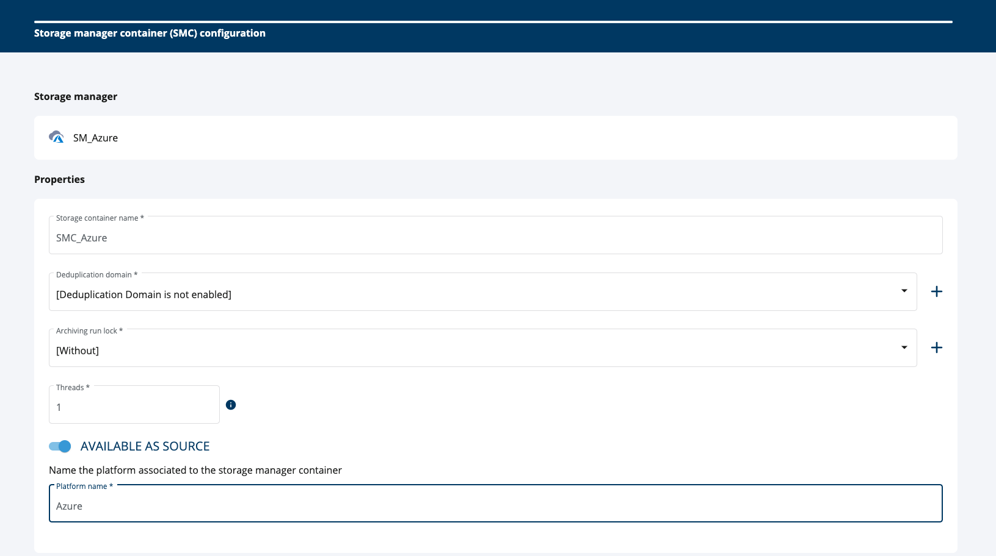

* 1. Scroll down to **Available as Source** toggle and turn it **On** to support future workflows using this SMC as a source. Name the source **platform** (here Azure).



* 1. Scroll down to the Configuration section below and type Azure account name, its **Access Key** and **Container Name**

Access tier “Default” will match the one chosen during the Azure storage account creation (Step 3 above).

Then click **Create** at the very bottom. Your SMC is successfully created, click on Back to get back to the home screen.

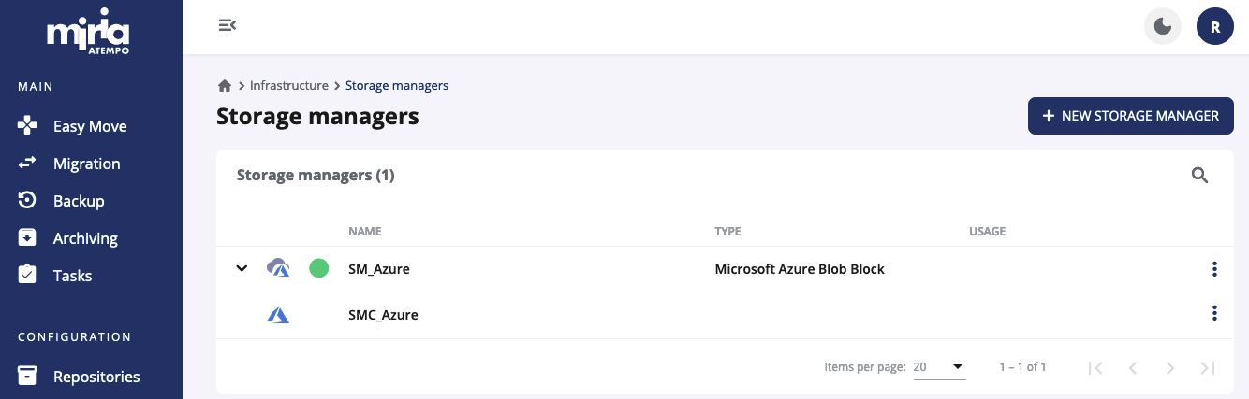

Congratulation! Your Azure storage and bucket are now fully declared and ready to use.

## Creating a Miria Source Storage for a Windows fileserver

1. In this example, we are moving data from an SMB/CIFS share of a Windows Fileserver (our source storage) to Azure (our target storage).  
   To create the source storage in Miria:
   * Navigate to the **Infrastructure** item on the left pane, then select **NAS**

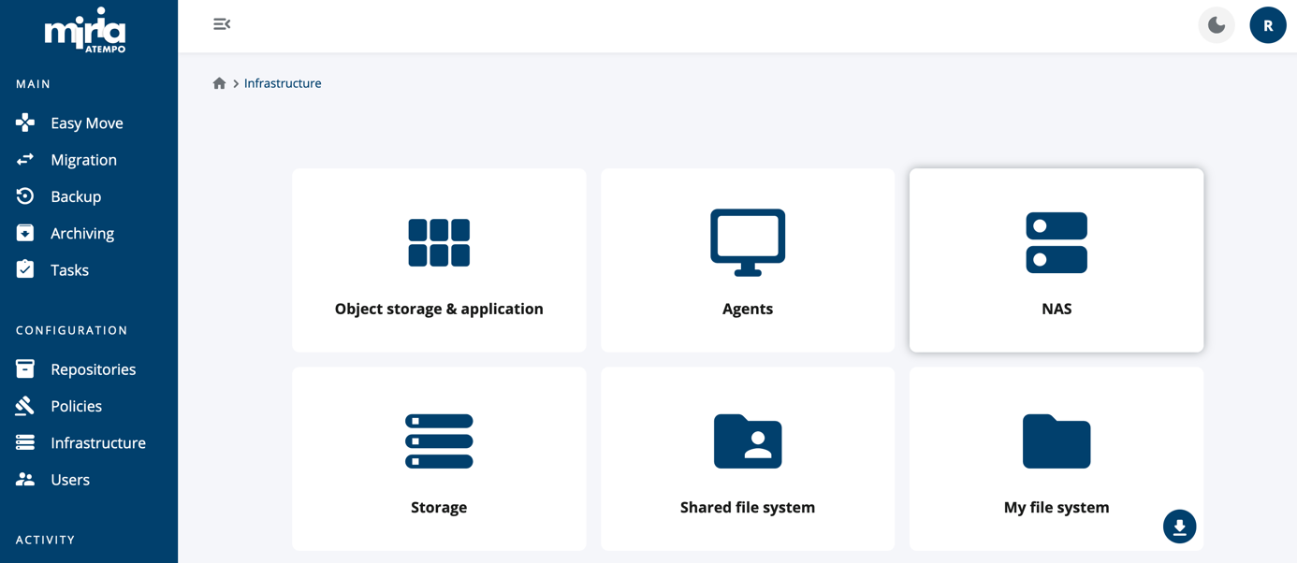

Click on **New NAS** at top right

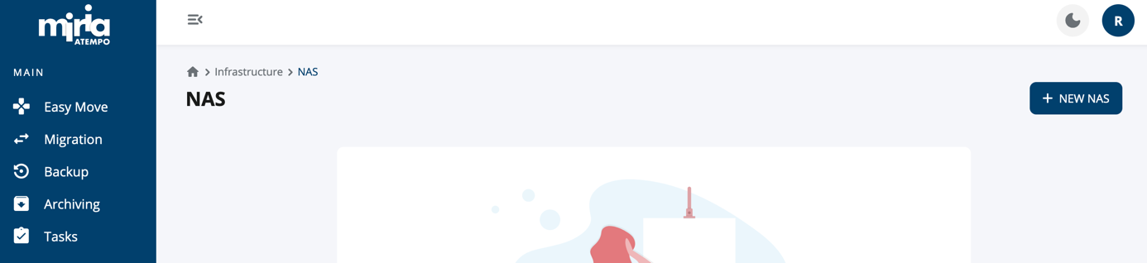

* + In the NAS Type drop-down list, select **Other**
  + In the Protocol radio button select **Windows (CIFS)**

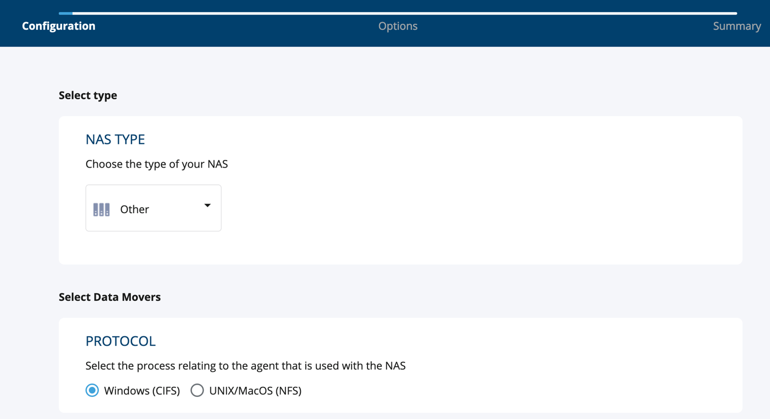

* + Under Data Movers, select Single agent or Pool (depending on your setup) and add a Windows Data Mover,
  + then click **Next** at the bottom right.

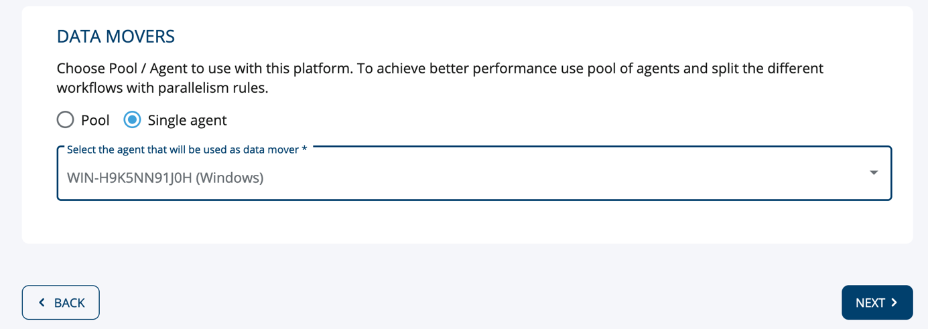

* + In the **Stream option** text box, add “host=” followed by FQDN (or IP address) of your NAS,
  + Click **Next**

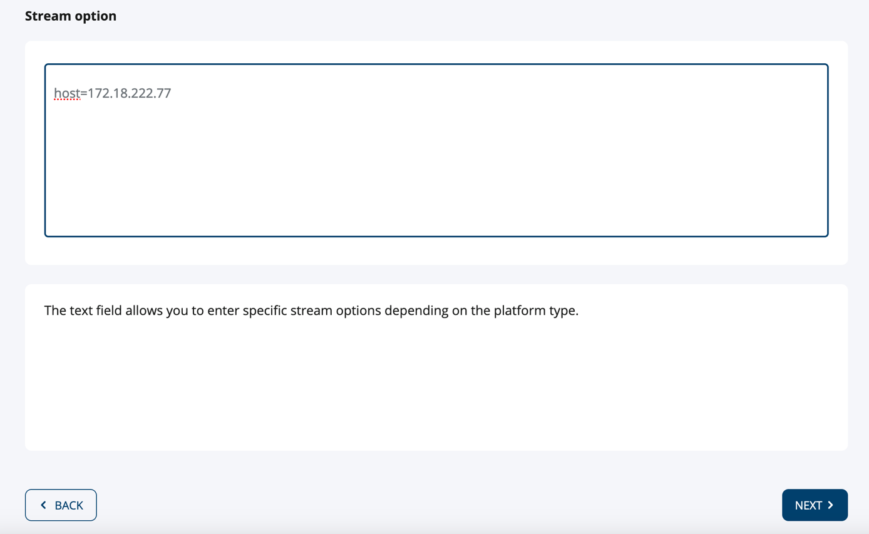

* + Select a NAS name
  + Add the **credentials** you want to use for data migration accessing this share
  + Click **Create**

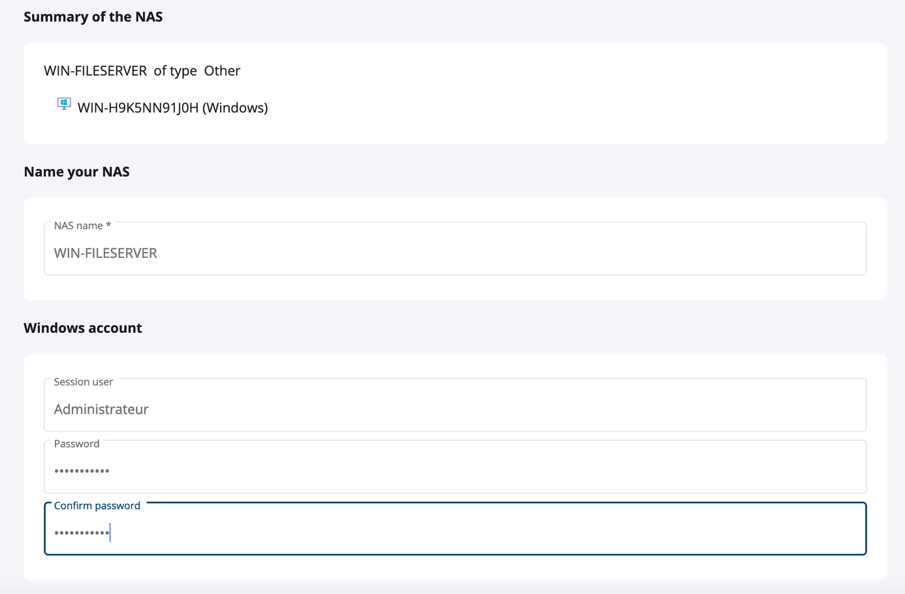



Your Windows fileserver is now ready to be used as a source.

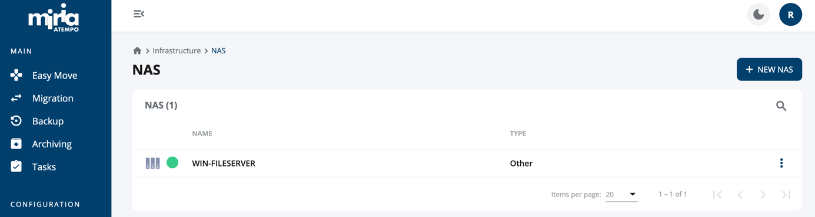

# Start Your Migration

## Creating and starting your data migration task

* 1. Now you can create your Migration project by selecting **Migration** in the left pane and **New Project**:

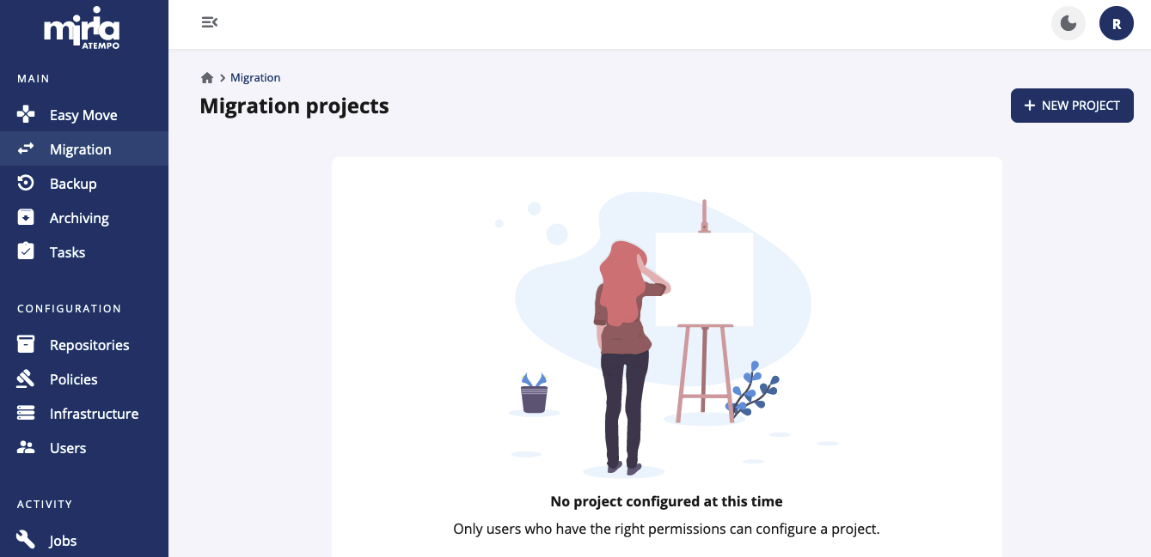

* 1. Select a project name and click on **New Project** button:

* 1. Select your source and target from the drop-down lists and click **Next**:

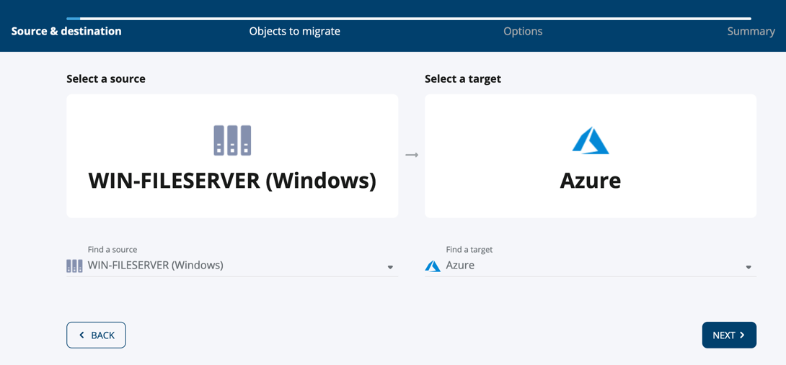

* 1. Select the folder containing data to migrate on the left side of the panel and click **Add** on the right. This folder will appear in the selection list located in the below section of the window:

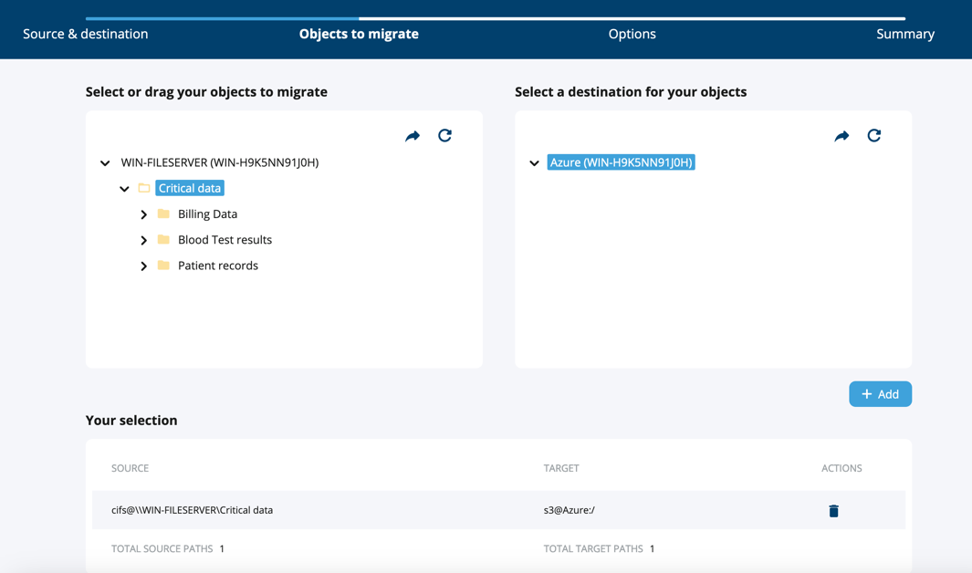

Once your folder selection is complete, click **Next**.

* 1. At this step you may select among different advanced options if needed. Review them and click **Next**.

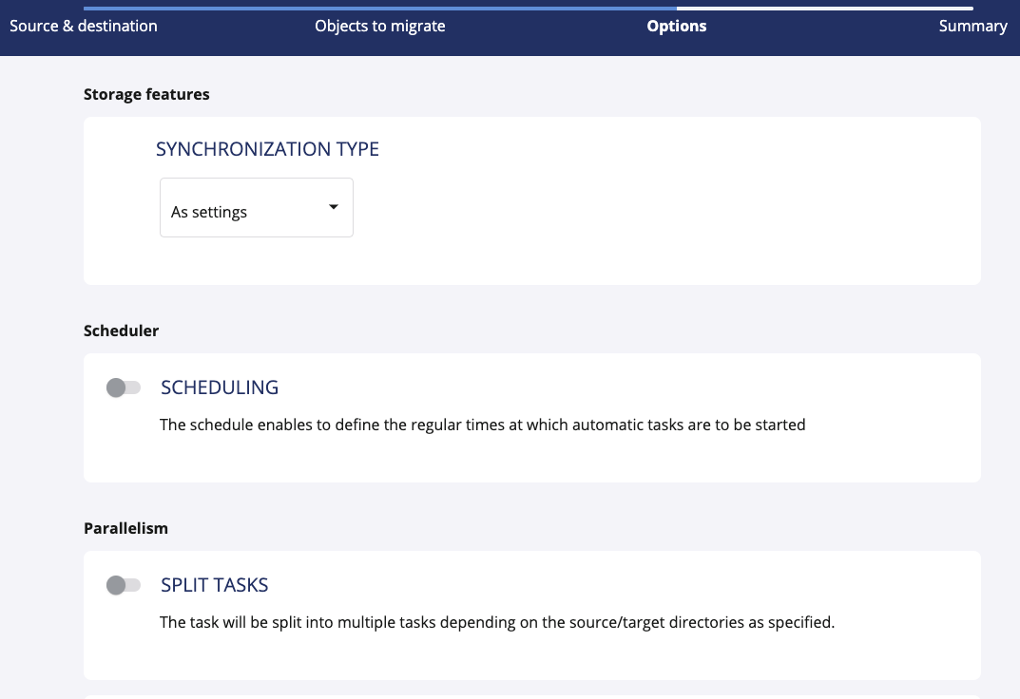

* 1. Select a name for your task then click **Create** .

* 1. You may now start your migration by clicking **Start**:

The task runs

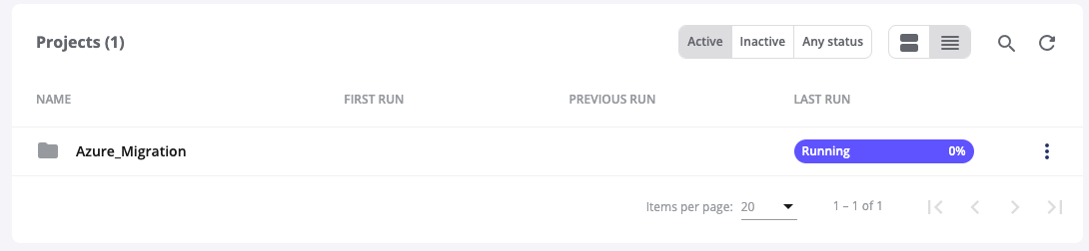

and after a period is completed.

You may monitor on the Azure side that your container is populated with your data.

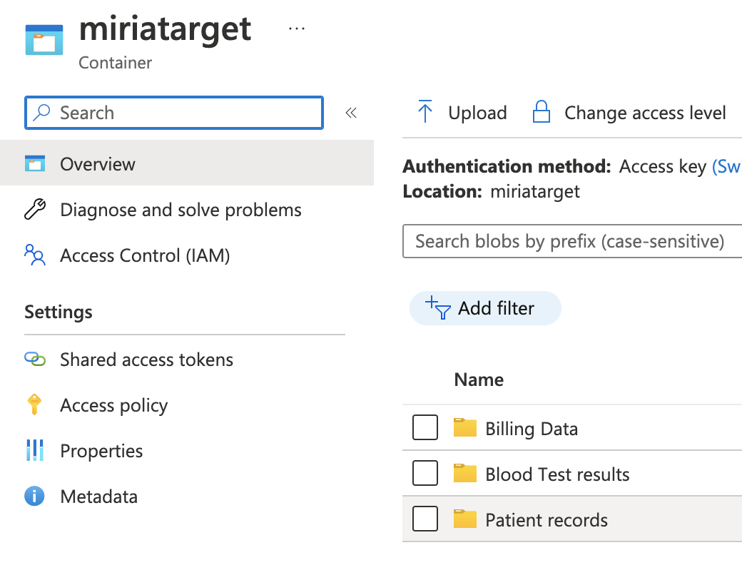

## Checking on migration progress, logs and reports

* 1. In the above step we have created two objects at once:
  + A migration project,
  + And a task in this migration project.

You might want to create a migration task per subset of data to migrate, for instance by usage, user group, department, project, etc. to have more control of the migration of each data sets.

The Web interface offer multiple option to check on progress:

* + at the project level: to get a global view of the progress of all tasks created in the project,
  + at the individual task level: to check on the progress for a specific task, i.e. data subset.
  1. To access the logs or more details on the tasks in this project, click on the three dots located at the end to display this menu:

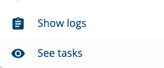

* + By selecting **Show logs** you will see the logs for all tasks in the project.
  + By selecting **See Tasks** you will get a graphical overview of the volume associated to all tasks as shown below.

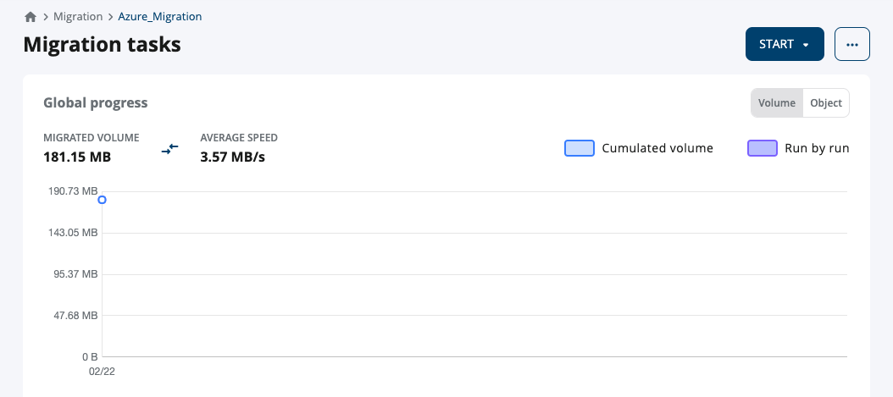

The above screenshot provides an overview of all iterations of the migration tasks in your project. Here for now, we have only one iteration for our task but we can easily launch a new iteration of the same task to collect all the latest and changed files since the last run by selecting the task in the bottom part of the panel and selecting **Start Task.** Each iteration of the task will be shown on the above graphic.

The bottom part of the screen is listing the tasks created in this project.

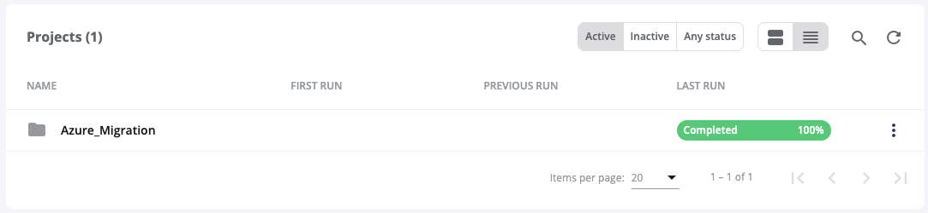

* 1. To drill down on an individual task, just apply a similar process, click on the three-dot menu at the end of the task line to display the task-related sub-menu:

* + By selecting **Show logs** you will see the logs for this task only.
  + By selecting **Integrity check** you will get access of the associated report for this task.
  + By selecting **See details** you will get a graphical volume report similar to the previous one but at task level as shown below:

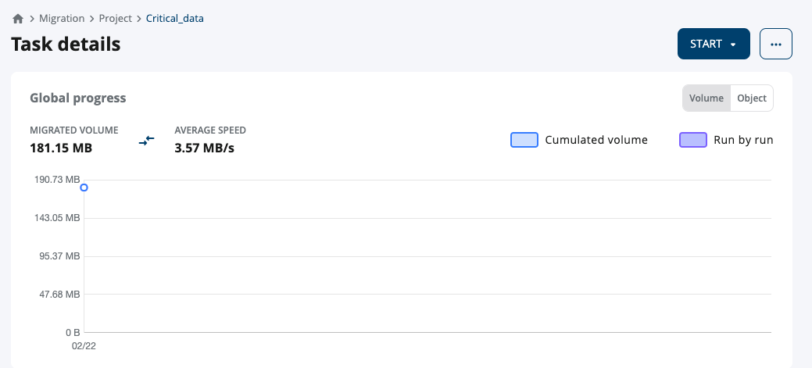

The lower part of the screen provides additional details on the job run.

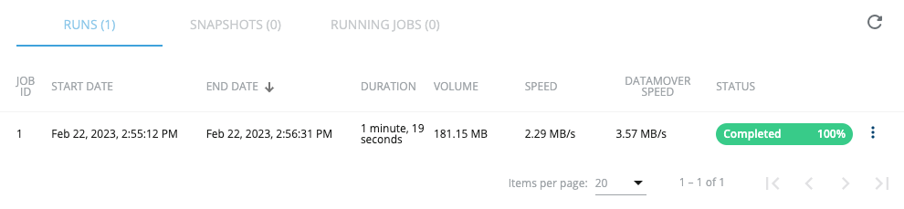

* 1. To download the report associated to this task, click the three-dot menu at the end of the line and select **Download Report.**

## Creating additional tasks in your migration project

* 1. More tasks can be added to a Migration project going back to the project level, by clicking the word **project** in the “bread crumb”:



* 1. To add a task, use the top menu with the three horizontal dots, select **New Task** and follow a similar process to create your task within the project.

After adding multiple tasks to the project, the **Start** menu on the top provides a way to start new iterations for all the tasks in this project at once.

# Support

When you need help with your migration to Azure solution, you should open a case with both Atempo and Azure.

## To Open A Case With Atempo

On the [Atempo Support Site](https://support.atempo.com/), sign into your account using the credentials received with your Miria package and open a case.

## To Open A Case With Azure

In the [Azure portal](https://portal.azure.com/) search for **support** in the search bar at the top. Select **Help + support** -> **New Support Request**.

# Marketplace

For more information, see the following references:

* [Miria’s entry in the Azure marketplace](https://azuremarketplace.microsoft.com/en-us/marketplace/apps/atempo_miria_migration.azure_migration_program)

# Next steps

Learn more about the process and recommendations for migrating data to Azure Storage:

* [Azure Storage migration overview](https://learn.microsoft.com/en-us/azure/storage/common/storage-migration-overview)

Learn more about Miria, its configuration, and deployment by visiting the documentation provided with your Miria product package:

* Miria for Migration
* Miria User Manual
* Miria Installation and Getting Started

## Feedback